**User Manual for Final Project**

1. The program will begin by greeting the user to Risorgimento. It will then prompt the user if they would like to use self-checkout or have a cashier checkout. The program will repeat this code until the user either enters 1 or 2.



1. If the user chooses self-checkout by entering 1:
   1. The user is prompted to enter their ID and password. If they enter the wrong username and password, they will prompted to enter it again, as it is expected that users that are using the self-checkout option have registered previously. Using the entered ID and password, the program will then check if the user has regular loyalty or executive member loyalty.



* 1. Once the user has entered their ID and password, they will be prompted to enter an integer amount of items for each inventory. The program will also display the price per unit for each item.

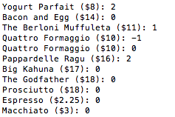

* 1. When the user has entered all items, the program will then output a summary of the user’s purchases, their subtotal and the total with the percent discount according to their membership level:

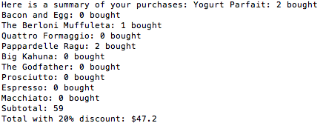

* 1. The program will then ask the user for payment. If the user enters less than the total price, the program will ask for the payment again. If the user enters more than needed, the program will return the change



* 1. Finally, the program will output a good-bye message

1. If the user chooses cashier checkout
   1. The user is prompted to enter their ID and password. Using the entered ID and password, the program will then check if the user has regular loyalty or executive member loyalty and store this information. If the user is not registered, entering ID as 0 and the password as 0 (or any unregistered ID and password) will direct them into the regular workflow.



* 1. The cashier will then be prompted to enter their ID and password. This will loop until the cashier has entered the right ID and password:



* 1. A welcome message is then displayed to the cashier portion of the program. The user is then prompted to either enter 1 to buy items or press 2 to update information. If the user enters 1, the program shifts to the base class buyItems() function and follows steps 2b – 2d. This will repeat until the user enters 1 or 2.



* 1. If the user enters 2, then the program will output the data management screen. The user will be prompted to enter 1 to review information, 2 to update information, 3 to sign up for loyalty/membership, and 4 to quit

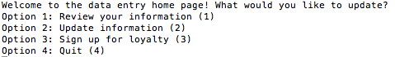

* 1. If the user enters 1, then the program will output all information about the user.



* 1. If the user enters 2, the user will be prompted to change every single field if he/she wants to. Before updating the field, the program will ask the user if they would like to update the particular field. If so, the program will ensure that the user enters a unique field that is different than the previous field and unique (only for ID). If the user doesn’t want to update the particular field, the program will move on to another field. The only field that is not updated is loyalty.

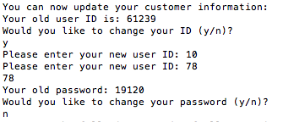

* 1. If the user enters 3, the user will be doing the same functions as step 3f, but the user can also enter the type of loyalty they would like. Furthermore, this is akin to making a new account, so users will have no option to change the ID or password.

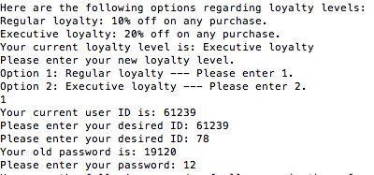

* 1. If the user enters 4, the program quits. At the end of every previous step, the program will output a summary of all user IDs sorted in ascending order. It will also output a goodbye message. It will then return the cashier to step 3c.

